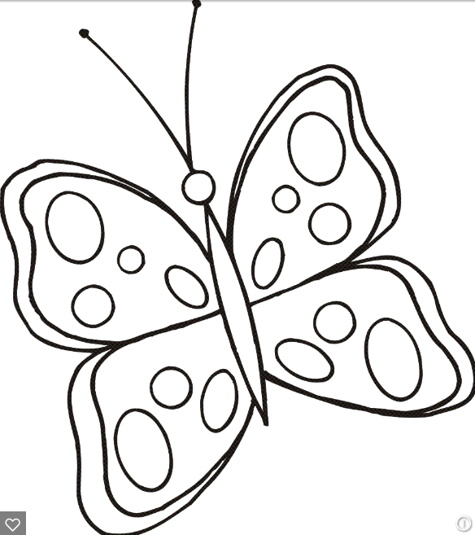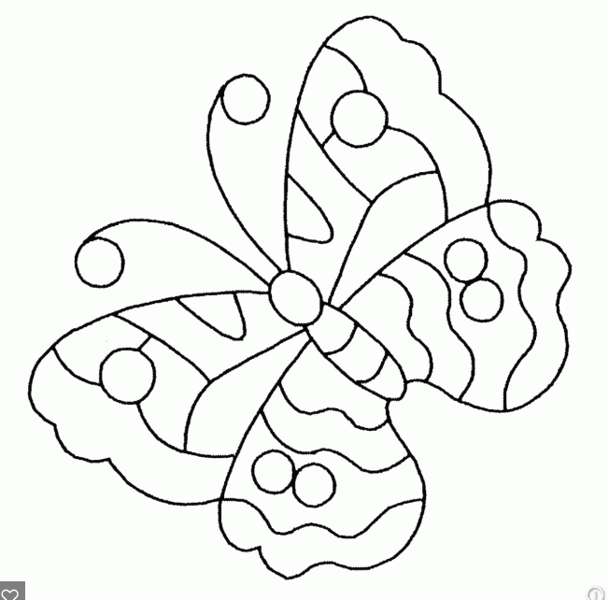

Directions: Please color the butterfly to show symmetry.

Directions: Please color the butterfly to show symmetry.

Directions: Please color the butterfly to show symmetry.

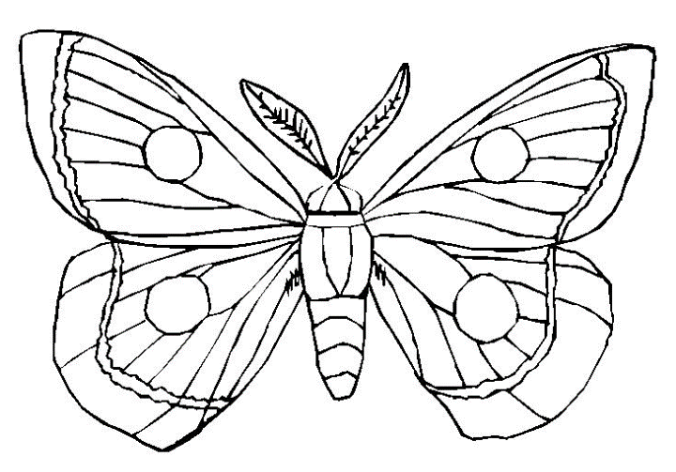

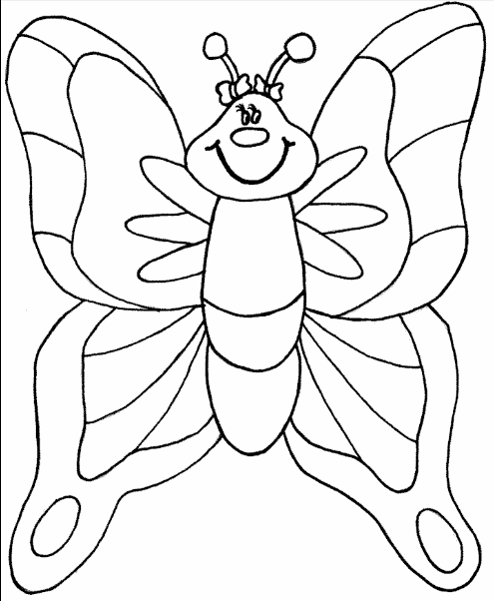

Directions: Please color the butterfly to show symmetry.