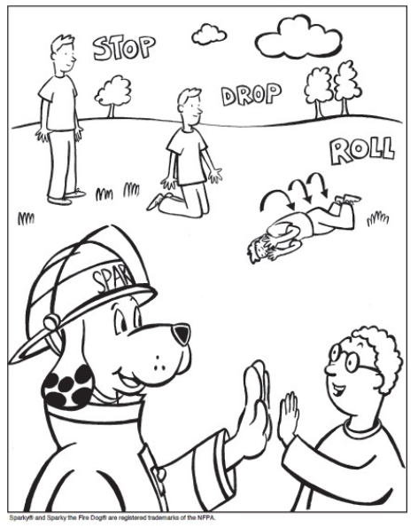

We learned about Fire Safety Rules in Library Media today!

Name: