Greek Mythology Heroes

Title of Myth | Perseus | Name of Greek Hero:  ______________________________________________
 | 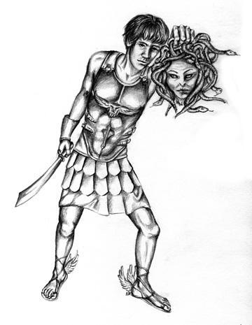
What is the hero’s ultimate goal?
Does this hero receive help from a god/goddess?
What amazing feats does this hero conquer?
What heroic qualities, character traits, or super human abilities does this hero have?
Does the myth explain a lesson learned or natural phenomena?
Do you believe this character is a hero? Explain why or why not.

Greek Mythology Heroes Chart

