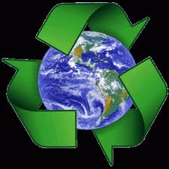 **Who Is Really Helping the Earth?**

*With your partner, take turns reading each sentence below. Then, decide whose is helping the Earth and who is not.*

|  |  |  |  |
| --- | --- | --- | --- |
| 1. | Ms. McElwee’s class planted trees behind the schools playground. | C:\Users\emcelwee\AppData\Local\Microsoft\Windows\Temporary Internet Files\Content.IE5\4NWK5CRT\MC900389004[1].wmf | Choose an item. |
| 2. | Joey throws cans in the trash can. | C:\Users\emcelwee\AppData\Local\Microsoft\Windows\Temporary Internet Files\Content.IE5\4NWK5CRT\MC900434769[1].png **→** C:\Users\emcelwee\AppData\Local\Microsoft\Windows\Temporary Internet Files\Content.IE5\9RI46B82\MC900030334[1].wmf | Choose an item. |
| 3. | Ben brings his lunch in a lunch box each day. | C:\Users\emcelwee\AppData\Local\Microsoft\Windows\Temporary Internet Files\Content.IE5\4NWK5CRT\MC900440524[1].wmf | Choose an item. |
| 4. | Jenny lets the water run while she brushes her teeth at bedtime. | C:\Users\emcelwee\AppData\Local\Microsoft\Windows\Temporary Internet Files\Content.IE5\70OVX4IR\MC900030370[1].wmf | Choose an item. |
| 5. | Mary uses BOTH sides of her note book paper. | C:\Users\emcelwee\AppData\Local\Microsoft\Windows\Temporary Internet Files\Content.IE5\FYRMNDPL\MC900290926[1].wmf | Choose an item. |

Partners are: _________________________________ and ___________________________________