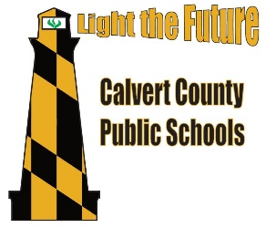
Calvert County Public Schools – Library Media Lesson Plan
Grade Level & Title: Grade 2 Building a Library Community (Lessons 1 & 2)
Lesson Overview: | This lesson is meant for the first week of school to review media center rules and expectations. Also, to review the physical space of the media center and how students locate the books they need and want.
Standards: | 1.1.2 Use prior and background knowledge as context for new learning.  1.1.2.1 Connect ideas to own interests.  1.1.4 .2 Distinguish between fiction and nonfiction books.  1.1.4 .3 Understand that the library has an organizational scheme.  1.1.9.1 Listen to others with respect.  1.1.9.2 Share knowledge and ideas with others by discussion and listening.  1.4.4 Seek appropriate help when it is needed.  1 Creativity and Innovation: Students demonstrate creative thinking, construct knowledge, and develop innovative products and processes using technology.  1.b Create original works as a means of personal or group expression  5.A.2.a Contribute to a learning community.  TL.2.3.A.1 Use and understand how technology enhances learning  TL.2.4.B.1.a Use multimedia tools to express original ideas with print, drawings, digital images, existing video, sounds, and/or personal recordings
Prior Knowledge: | - Library procedures and rules from previous grade level  - Using Wixie tools  - Distinguishing between fiction and non-fiction  - Information found on the cover of a book
Student Objectives: | Students will…  - Associate the media center with a place of learning and as a place where they can locate and check-out a book  - Discuss the expectations of student behavior and productivity in the media center  - Identify proper book check-out rules and procedures and book care rules  - Distinguish between fiction and non-fiction  - Locate the different areas of the media center  - Recognize what a call number is and how it helps us locate books  - Demonstrate the ability to access Wixie  - Demonstrate the ability to use Wixie tools appropriately and effectively to complete a project
Materials: | 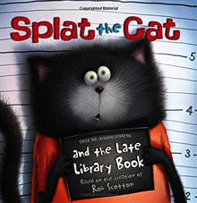  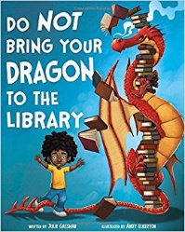  Book of your choice for grade 2 early weeks of media. Everyone has their favorites!
Engagement Question: | Class Period 1: How do we show respect, be responsible, and keep ourselves and others safe in the media center?  Class Period 2: How can we find books in the media center that meet our informational and entertainment needs?
Lesson Procedures: | Class Period 1:  - Read your favorite first week book  - Use the Smartboard slides to have an open discussion about the words on the media manners slide. For example… what does “respect” look like in the media center.  - Brainstorm library rules together and make a student generated list either using the given slide or some other list making tool  - Brainstorm ideas about book care  - Review the complete library check-out procedures  - Tour the library together to help familiarize the students with where they would find their favorite books  Class Period 2:  - Read another favorite beginning of the school year book  - Use the Smartboard slides to review basic library words such as fiction and non-fiction  - Ask the students if they remember what the little white sticker is called on the spine (review word) of all the books (there is a slide with a picture of the book spine and the call number)  - Equate the call number to an address label for the book so we know where it “lives” in the library  - Discuss how fiction is arranged By ABC order by the author’s last name. There is a slide for putting aliens in ABC order if time and ability permit  - There is a Wixie/Pixie for library rules and book care if your students are familiar with accessing & using Wixie/Pixie  - Instead of using technology this 2nd class, I would allow extra time for book check-out and time for the students to enjoy the media center quietly reading with free seating options.
Closure/Exit: | Class Period 1: While students are in line have them give you a book care rule or a media center rule.  Class Period 2: While students are in line with their newly checked-out book have them hold them up and tell you if they are fiction or non-fiction as your travel down the line.
Other Resources: | - Bookflix offers Wild About Books and Welcome to the Library if you have a subscription.  - Pinterest! Links to free resources found on TPT, book lists, and other ideas for September in the media center.  - Links on Schoology  - Please add your great resources!

