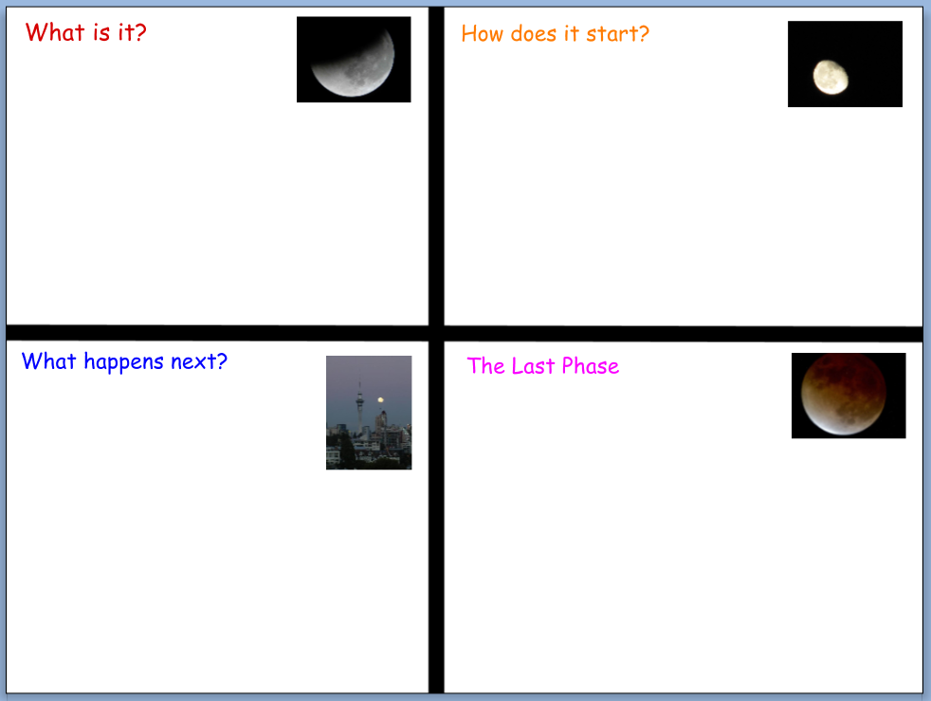

“Moon Phases” PebbleGo. www.pebblego.com December 2, 2015